**Figure 1: Importing and Installing pySpark in Google Colab**

**Figure 2: Loading the Data and ICE queries.**

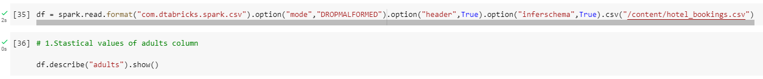

**Figure 3: 3rd Question**

